Data Structure and Algorithm

SSSP Exercise

Here is a graph (left) and its adjacency list (right). In the adjacency list, each node will point to another node with the left entry is the vertex index and the right value is the weight of the edge.

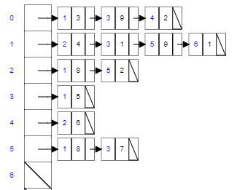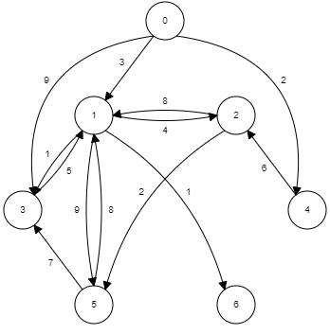

The neighbor vertex 0

An edge from vertex 0 to 1, and the weight is 3.

Perform Dijkstra Algorithm of this graph to find all the shortest distance from the node 0. Each of the following table is a priority queue sorted by the shortest estimated distance, δ(0,v).

|  |  |  |  |  |  |  |  |  |  |  |  |  |
| --- | --- | --- | --- | --- | --- | --- | --- | --- | --- | --- | --- | --- |
| Node v | δ(0,v) |  | Node v | δ(0,v) |  | Node v | δ(0,v) |  | Node v | δ(0,v) |  |  |
| 0 | 0 |  | 4 | 2 |  | 1 | 3 |  | 3 | 4 |  |  |
| 1 | ∞ |  | 1 | 3 |  | 2 | 8 |  | 6 | 4 |  |  |
| 2 | ∞ | Extract | 3 | 9 | Extract | 3 | 9 | Extract | 2 | 7 | Extract |  |
| 3 | ∞ | 0 |  |  | ___ |  |  | ___ | 5 | 12 | ___ |  |
| 4 | ∞ | 🡪 |  |  | 🡪 |  |  | 🡪 |  |  | 🡪 |  |
| 5 | ∞ |  |  |  |  |  |  |  |  |  |  |  |
| 6 | ∞ |  |  |  |  |  |  |  |  |  |  |  |

|  |  |  |  |  |  |  |  |  |  |  |  |  |
| --- | --- | --- | --- | --- | --- | --- | --- | --- | --- | --- | --- | --- |
| Node v | δ(0,v) |  | Node v | δ(0,v) |  | Node v | δ(0,v) |  | Node v | δ(0,v) |  |  |
| 6 | 4 |  | 2 | 7 |  | 5 | 9 |  |  |  |  |  |
| 2 | 7 |  | 5 | 12 |  |  |  |  |  |  |  |  |
| 5 | 12 | Extract |  |  | Extract |  |  | Extract |  |  |  |  |
|  |  | ___ |  |  | ___ |  |  | ___ |  |  |  |  |
|  |  | 🡪 |  |  | 🡪 |  |  | 🡪 |  |  |  |  |

Another Graph for your practice.

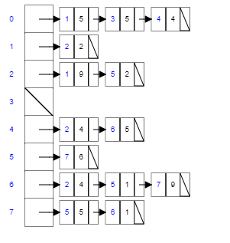

The neighbor vertex 0

An edge from vertex 0 to 1, and the weight is 3.

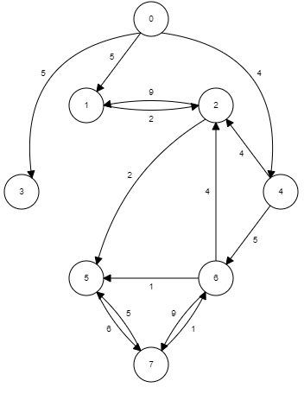

|  |  |  |  |  |  |  |  |  |  |  |  |  |
| --- | --- | --- | --- | --- | --- | --- | --- | --- | --- | --- | --- | --- |
| Node v | δ(0,v) |  | Node v | δ(0,v) |  | Node v | δ(0,v) |  | Node v | δ(0,v) |  |  |
| 0 | 0 |  | 4 | 4 |  | 1 | 5 |  | 3 | 5 |  |  |
| 1 | ∞ |  | 1 | 5 |  | 3 | 5 |  | 2 | 7 |  |  |
| 2 | ∞ | Extract | 3 | 5 | Extract | 2 | 8 | Extract | 6 | 9 | Extract |  |
| 3 | ∞ | 0 |  |  | ___ | 6 | 9 | ___ |  |  | ___ |  |
| 4 | ∞ | 🡪 |  |  | 🡪 |  |  | 🡪 |  |  | 🡪 |  |
| 5 | ∞ |  |  |  |  |  |  |  |  |  |  |  |
| 6 | ∞ |  |  |  |  |  |  |  |  |  |  |  |

|  |  |  |  |  |  |  |  |  |  |  |  |  |
| --- | --- | --- | --- | --- | --- | --- | --- | --- | --- | --- | --- | --- |
| Node v | δ(0,v) |  | Node v | δ(0,v) |  | Node v | δ(0,v) |  | Node v | δ(0,v) |  |  |
| 2 | 7 |  | 5 | 9 |  | 6 | 9 |  | 7 | 15 |  |  |
| 6 | 9 |  | 6 | 9 |  | 7 | 15 |  |  |  |  |  |
|  |  | Extract |  |  | Extract |  |  | Extract |  |  |  |  |
|  |  | ___ |  |  | ___ |  |  | ___ |  |  |  |  |
|  |  | 🡪 |  |  | 🡪 |  |  | 🡪 |  |  |  |  |